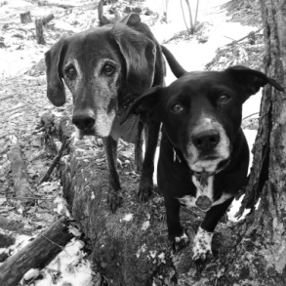
One Paw at a Time

Group Dog Training Classes Offered in Lebanon, NH at SAVES
Strengthen the bond you have with your canine companion using positive reinforcement training methods & a hands-off training approach

Sunday classes: May 5, 19, June 2, 9, 23

3:30pm – Good Dog 1 (for dogs 5.5 months and up who have never taken a class; great for newly adopted dogs; focus is on life skills; dogs do NOT attend week 1)

4:45pm – Maggie’s Boot Camp (for dogs ready to take training up to the next level; pre-requisite of level 1 class or instructor permission; class will cover skills, tricks, games, CGC requirements)

Fee for classes: $125

Kasandra Fleury, ABCDT
802-356-0718
vermonttrailpups2@gmail.com

