2019 Teaching Schedule CARON BRONSTEIN
START DATES and TIMES listed below Dog Obedience Instruction
6 week sessions meet weekly same day & AKC Canine Good Citizen Evaluator time for 1 hour. 5 week sessions meet weekly
for 1 hr. 15 min. 603-398-2293

All classes taught at SAVES yarboroughlabs@gmail.com
OBEDIENCE 1 (Beginner) Obedience classes - $125 / 6 week session
Tuesday 11:00 pm May 28 Rally Obedience - $80 / 3 hr. workshop Wednesday 6:00 pm May 29 Drop-in or pay weekly - $25 / class
Monday 6:00 pm June 3 Private consultations - $75 / hour
Monday 6:00 pm July 15 Tuesday 10:00 am July 16 SAVES – Small Animal Veterinary Emergency
Wednesday 6:00 pm July 17 Services, I-89 Exit 18, Lebanon, NH
Monday 6:00 pm Sept. 9 LUCY MAC – Lucy Mackenzie Humane Society
Tuesday 10:00 am Sept. 10 Rte. 44, West Windsor, VT
Wednesday 6:00 pm Sept. 11

OBEDIENCE 2 (Intermediate)
Tuesday 10:00 am May 28 PRE-REGISTRATION AND
Thursday 6:00 pm May 30 PRE-PAYMENT RECOMMENDED
Monday 6:00 pm June 3
Monday 6:00 pm July 15
Tuesday 11:00 am July 16
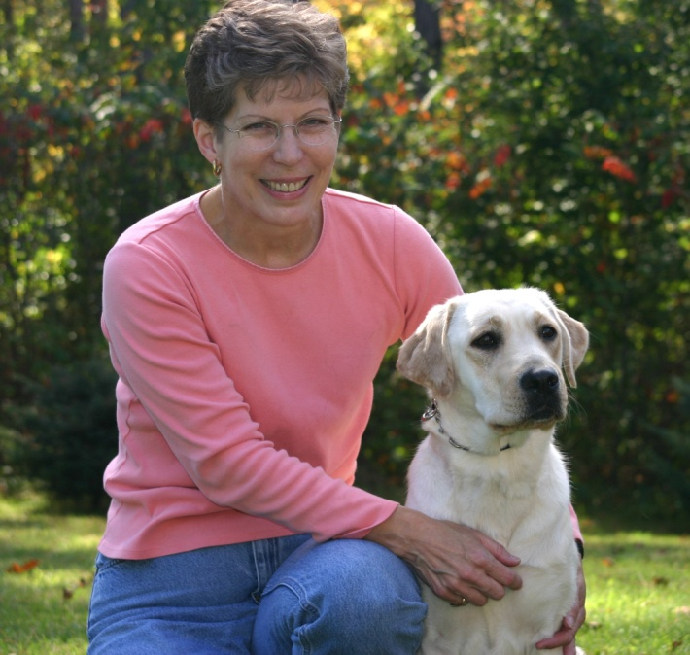
Thursday 6:00 pm July 18
Thursday 6:00 pm Sept. 5
Monday 6:00 pm Sept. 9
Tuesday 11:00 am Sept. 10

OBEDIENCE 3 (Advanced)
Tuesday 12:00 pm May 28
Tuesday 12:00 pm July 16
Tuesday 12:00 pm Sept. 10

COMPETITION OBEDIENCE (rolling admission)
Tuesday 1:00 pm May 28
Wednesday 7:00 pm May 29
Tuesday 1:00 pm July 16
Wednesday 7:00 pm July 17

RALLY OBEDIENCE WORKSHOPS
@ LUCY MACKENZIE HUMANE SOCIETY
Sunday 8 am – 11 am June 30
12 pm – 3 pm June 30 LUCY MAC CLASSES – Tuesday evening &
AM: Novice/Intermediate Saturday morning. Call/email:
PM: Advanced/Excellent/ Masters 802-484-5829 or lucymac.org

