2018 - 2019 Teaching Schedule CARON BRONSTEIN
START DATES and TIMES listed below Dog Obedience Instruction
6 week sessions meet weekly same day & AKC Canine Good Citizen Evaluator time for 1 hour. 5 week sessions meet for 603-398-2293
1 hr. 10 min.

All classes taught at SAVES yarboroughlabs@gmail.com
OBEDIENCE 1 (Beginner) Obedience classes - $120 / 6 week session
Tuesday 11:00 am Oct. 16 Rally Obedience - $75 / 3 hr. workshop Monday 6:00 pm Oct. 22 Drop-in or pay weekly - $25 / class
Wednesday 6:00 pm Oct. 24 Private consultations - $70 / hour
Wednesday 6:00 pm Jan. 2, 2019 Monday 6:00 pm Jan. 7 SAVES – Small Animal Veterinary Emergency
Tuesday 11:00 am Jan. 8 Services, I-89 Exit 18, Lebanon, NH
Monday 6:00 pm Mar. 4 LUCY MAC – Lucy Mackenzie Humane Society,
Tuesday 11:00 am Mar. 5 Rte. 44, West Windsor, VT
Wednesday 6:00 pm Mar. 6

OBEDIENCE 2 (Intermediate)
Tuesday 10:00 am Oct. 16 PRE-REGISTRATION AND
Monday 7:00 pm Oct. 22 PRE-PAYMENT RECOMMENDED
Thursday 6:00 pm Oct. 25
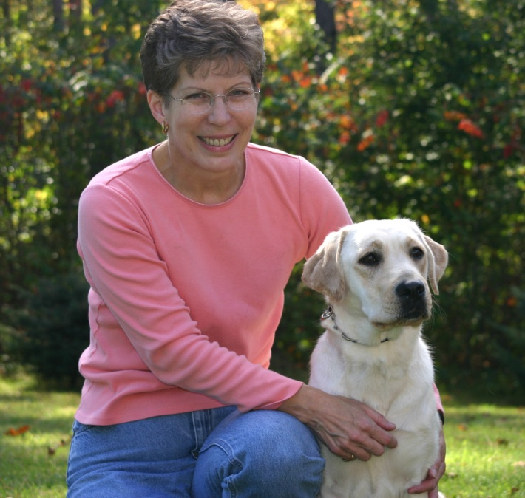
Thursday 6:00 pm Jan. 3, 2019
Monday 7:00 pm Jan. 7
Tuesday 10:00 am Jan. 8
Monday 7:00 pm Mar. 4
Tuesday 10:00 am Mar. 5
Thursday 6:00 pm Mar. 7

OBEDIENCE 3 (Advanced)
Tuesday 12:00 pm Oct. 16
Tuesday 12:00 pm Jan. 8, 2019
Tuesday 12:00 pm Mar. 5

COMPETITION OBEDIENCE (rolling admission)
Tuesday 1:00 pm Oct. 16
Wednesday 7:00 pm Oct. 24
Wednesday 7:00 pm Jan. 2, 2019
Tuesday 1:00 pm Jan. 8
Tuesday 1:00 pm Mar. 5
Wednesday 7:00 pm Mar. 6

RALLY OBEDIENCE WORKSHOPS
@ LUCY MAC
Sunday 9 am – 12 pm Oct. 28
1 pm – 4 pm Oct. 28 LUCY MAC CLASSES – Tuesday evening &
AM: Novice/Intermediate Saturday morning. Call/email:
PM: Advanced/Excellent/ Masters 802-484-5829 or lucymac.org

