2018 Teaching Schedule CARON BRONSTEIN
START DATES and TIMES listed below Dog Obedience Instruction
6 week sessions meet weekly same day & AKC Canine Good Citizen Evaluator time for 1 hour. 603-398-2293
yarboroughlabs@gmail.com
All classes taught at SAVES

OBEDIENCE 1 (Beginner) Obedience classes - $120 / 6 week session
Tuesday 11:00 am May 29 Rally Obedience - $75 / 3 hr. workshop Wednesday 6:00 pm May 30 (5 wk.) Drop–In Fee - $25 / class
Monday 6:00 pm June 4 Private consultations - $70 / hour
Tuesday 11:00 am July 10 Wednesday 6:00 pm July 11 SAVES – Small Animal Veterinary Emergency
Monday 6:00 pm July 16 Services, I-89 Exit 18, Lebanon, NH
Tuesday 11:00 am Sept. 4 LUCY MAC – Lucy Mackenzie Humane Society,
Wednesday 6:00 pm Sept. 5 Rte. 44, West Windsor, VT
Monday 6:00 pm Sept. 10

OBEDIENCE 2 (Intermediate)
Tuesday 10:00 am May 29 PRE-REGISTRATION AND
Thursday 6:00 pm May 31 (5 wk.) PRE-PAYMENT RECOMMENDED
Monday 7:00 pm June 4
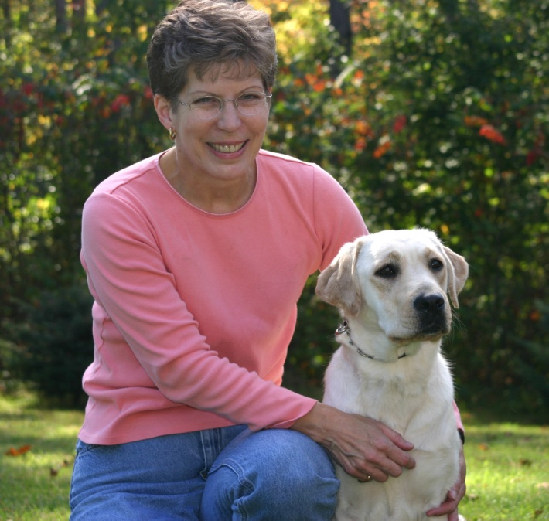
Tuesday 10:00 am July 10
Monday 7:00 pm July 16
Thursday 6:00 pm July 19
Tuesday 10:00 am Sept. 4
Thursday 6:00 pm Sept. 6
Monday 7:00 pm Sept. 10

OBEDIENCE 3 (Advanced)
Tuesday 12:00 pm May 29
Tuesday 12:00 pm July 10
Tuesday 12:00 pm Sept. 4

COMPETITION OBEDIENCE (rolling admission)
Tuesday 1:00 pm May 29
Wednesday 7:00 pm May 30
Thursday 7:00 pm May 31

RALLY OBEDIENCE WORKSHOPS
@ LUCY MAC
Sunday 9 am – 12 pm June 10
1 pm – 4 pm June 10 LUCY MAC CLASSES – Tuesday evening &
AM: Novice/Intermediate Saturday morning. Call/email:
PM: Advanced/Excellent/ Masters 802-484-5829 or lucymac.org

